L5a-W6-DBS301-Simple Joins

**Name : Avinash Singh**

**Course : DBS301**

**Proffessor : Ayesha manzer**

**Lab 5A**

**Date : 6-Oct-2017.**

**NOTE 1: This is about simple joins, so no LEFT or RIGHT joins etc. Required.**

**NOTE 2: There is a 5b on joins that also needs to be done**

**NOTE 3: If you are not finishing this in week 5, then you are actually running behind. The labs have been extended to week 6 to submit. Please catch up.**

1. Display the department name, city, street address and postal code for departments sorted by city and department name.

**Query:**

**SELECT D.DEPARTMENT_NAME AS “Department Name”,**

**L.CITY,**

**L.STREET_ADDRESS AS “Street Address”,**

**L.POSTAL_CODE AS “Postal Code”**

**FROM DEPARTMENTS D, LOCATIONS L**

**WHERE D.LOCATION_ID = L.LOCATION_ID**

**ORDER BY L.CITY, D.DEPARTMENT_ID;**

**Result:**

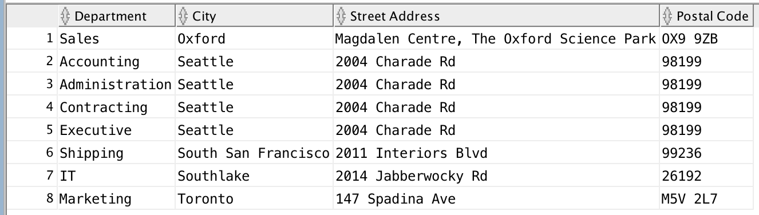

1. Display full name of employees as a single field using format of **Last,** **First**, their hire date, salary, department name and city, but only for departments with names starting with an **A** or **S** sorted by department name and employee name.

**Query:**

SELECT E.LAST_NAME || ', ' || E.FIRST_NAME AS “Full Name”,

E.HIRE_DATE AS “Hire Date”,

E.SALARY,

D.DEPARTMENT_NAME AS “Department Name”,

L.CITY

FROM EMPLOYEES E, DEPARTMENTS D, LOCATIONS L

WHERE E.DEPARTMENT_ID = D.DEPARTMENT_ID

AND D.LOCATION_ID = L.LOCATION_ID

AND SUBSTR(D.DEPARTMENT_NAME,1,1) IN ('A','S')

**Result:**

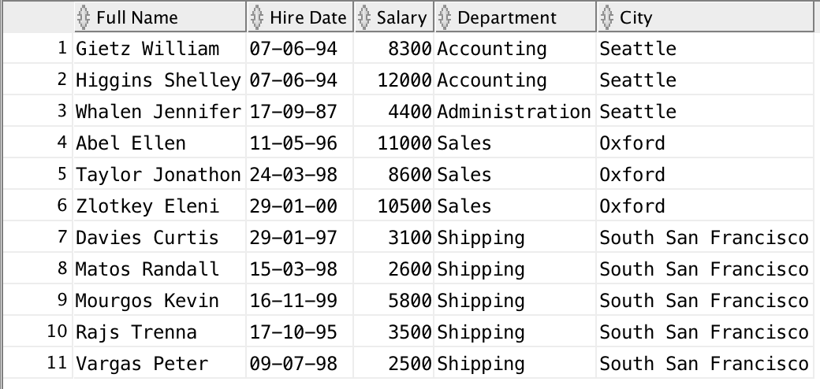

1. Display the full name of the manager of each department in states/provinces of Ontario, California and Washington along with the department name, city, postal code and province name. Sort the output by city and then by department name.

**Query:**

**SELECT E.FIRST_NAME || ' ' || E.LAST_NAME AS "FULLNAME",**

**D.DEPARTMENT_NAME,**

**L.CITY,**

**L.POSTAL_CODE,**

**L.STATE_PROVINCE**

**FROM EMPLOYEES E, DEPARTMENTS D, LOCATIONS L**

**WHERE E.DEPARTMENT_ID = D.DEPARTMENT_ID**

**AND D.LOCATION_ID = L.LOCATION_ID**

**AND L.STATE_PROVINCE IN ('Ontario', 'California', 'Washington')**

**AND (E.JOB_ID LIKE '%MGR%'**

**OR E.JOB_ID LIKE '%MAN%')**

**ORDER BY L.CITY, D.DEPARTMENT_NAME;**

**Results:**

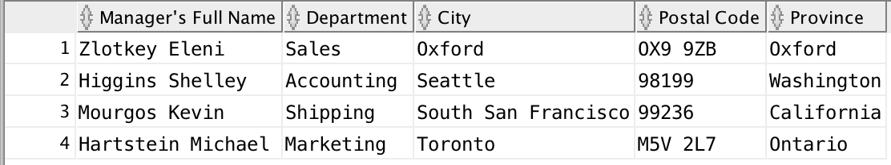

1. Display employee’s last name and employee number along with their manager’s last name and manager number. Label the columns Employee, Emp#, Manager, and Mgr# respectively.

**Query:**

**SELECT E1.LAST_NAME AS "Employee",**

**E1.EMPLOYEE_ID AS "Employee Number",**

**E2.LAST_NAME AS "Manager",**

**E2.MANAGER_ID AS "Manager Number"**

**FROM EMPLOYEES E1, EMPLOYEES E2**

**WHERE E1.MANAGER_ID = E2.EMPLOYEE_ID;**

**Results:**

